Consumer Costs of Water Shortage: Overview and Empirical Evidence
David Mitchell
February 11, 2015
A key question in water utility planning is how much supply is enough? In most developed countries, water utility customers have come to expect that water will be available when, where, and in the quantity they want it. This “on-demand” service model requires that utilities size their water systems so they can meet maximum hour, day, and season demands without risk of running short. Where supply is variable, meeting demands reliably can impose significant costs on water systems and their customers if doing so requires building in supply redundancy. In such cases it is prudent to ask the question: is it worth it?
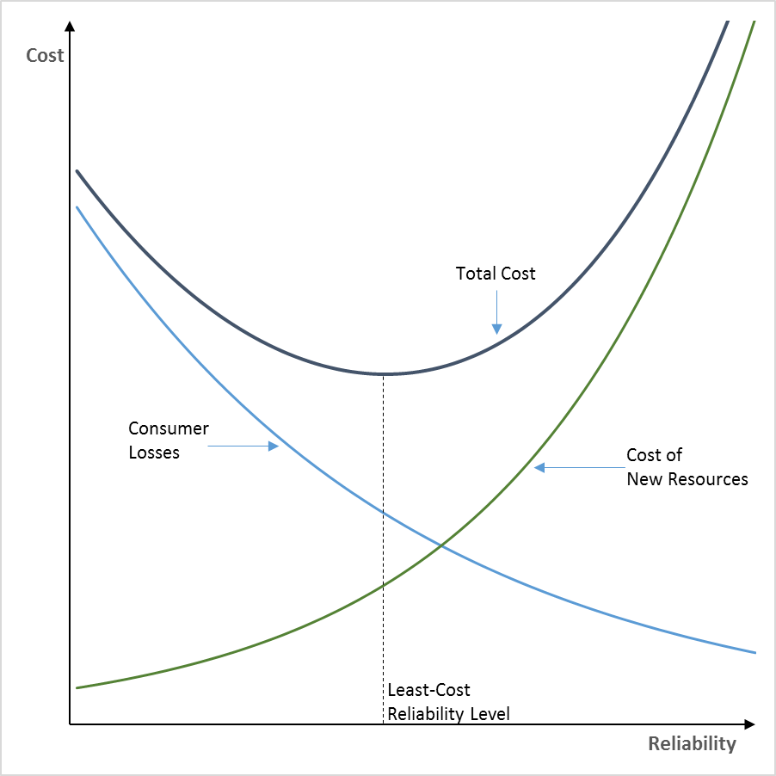
The answer depends in part on what costs consumers incur if their water demands are not met. That is, if during some periods, they must forgo consuming as much as they would like. Much of California is currently in such a situation, where water users have been asked, and in some cases mandated, to curb their consumption in order to balance available supplies with demand. It is clear consumers are made worse off when their consumption is restricted in this way. Had their use not been restricted, they would have freely chosen to purchase the restricted units of water at the prevailing water rate, so the water they had to give up is worth at least that much to them. And for most consumers it will be worth much more than that. Thus when reliability declines and the frequency or magnitude of shortages increases, consumer costs of forgone consumption go up. Conversely, when reliability improves and the frequency or magnitude of shortages decreases, consumer costs of forgone consumption go down. Note that consumer costs move in the opposite direction as system costs with changes in reliability. Increasing reliability raises system costs and lowers consumer costs and vice versa.
Figure 1. Total Cost of Water Supply Reliability
The forgoing means that reliability planning involves balancing consumer losses from shortages against system costs incurred to avoid such shortages. This is shown in Figure 1, which illustrates that beyond some point more reliability stops being worth it to consumers. That point is where the two lower lines in the figure cross. To the right of that point the cost of adding new resources to the system exceeds the consumer loss those new resources would mitigate. In other words, new resources beyond that point would not be worth it to consumers if their only purpose was to mitigate shortage losses.
For any given level of reliability, the total cost to the community is the consumer losses from shortages at that reliability level plus the resource cost incurred to provide that level of reliability. This is the u-shaped curve in Figure 1 labeled Total Cost. From a least-cost perspective, the reliability sweet spot occurs at the bottom of the u. At that level of reliability, total consumer cost is minimized. It is important to emphasize that resource cost is meant to be viewed broadly to include the full spectrum of socio-economic costs associated with adding new system resources, not simply the direct financial cost of a project.
A useful framework for translating water supply shortages into consumer losses is illustrated in Figure 2. As noted by Dixon, et al (1996), “the size of the water supply cutbacks, the drought management strategies adopted by water agencies, and customer response to these policies together determine the effect of water supply shortages on consumer welfare.”
Figure 2. Translating Water Supply Shortages into Consumer Losses
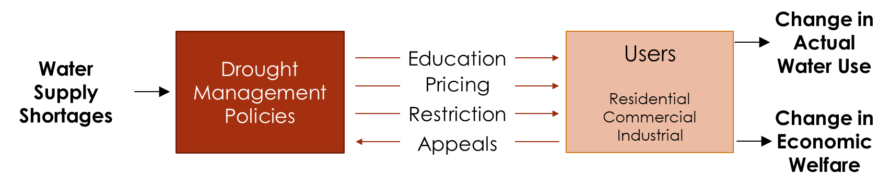
For residential water users, typical shortage-induced changes in economic welfare include:
- Constraints on behavior – such as shorter showers or restrictions on when or how water can be used.
- Quality of life impacts – such as desiccated landscapes, impaired parks and play fields, and dirty cars, windows, and hardscapes.
- Increased water costs due to drought rates or penalties.
- Increased household expenses for installing conservation fixtures or replacing destroyed landscaping.
For commercial and industrial water users, typical shortage-induced impacts include:
- Reduced profits due to restrictions on output, increases in production costs, or reductions in product or service demand.
- Reduced labor income and employment.
- Loss of customer goodwill and market share.
Measuring these impacts is an important though challenging empirical exercise that we do not delve into here. Rather, for the remainder of this brief, we provide an overview of some of the findings from the published empirical literature on economic costs of water shortages.
Residential Cost of Water Shortage
One measure of change in economic welfare that is widely used in the economics literature is willingness-to-pay (WTP). In the context of residential water shortages, WTP is defined as the maximum dollar amount households would be willing to pay to avoid the drought management strategies adopted by their water agencies. The ranges in WTP reported in four empirical studies of residential WTP to avoid water shortages lasting one-year are illustrated in Figure 3. Note that for low magnitude shortages (<= 15%), the low end of the range is zero, indicating that households may not find low magnitude shortages terribly disruptive and thus would be willing to pay little or nothing to avoid them. WTP increases with shortage magnitude, possibly in a non-linear fashion. The very large range in WTP for a 50% shortage reflects the rarity of such events and corresponding uncertainty in WTP to avoid them.
Figure 3. Residential WTP to Avoid Water Shortage Lasting One-Year
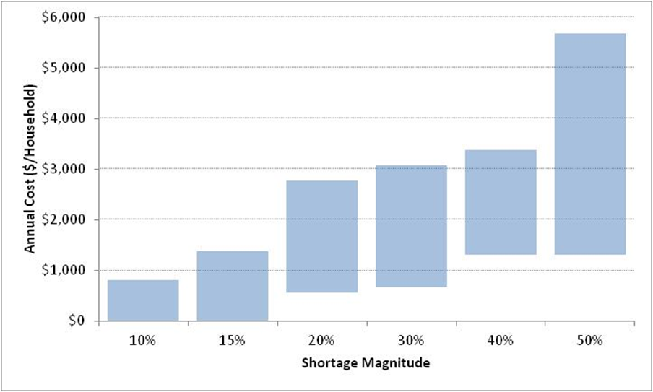

RAND examined residential impacts of water shortages resulting from California’s 1987-92 drought. It found the largest impacts were in the residential sector. Drought policies mostly shielded commercial and industrial users – though some sectors, such as the green industry were significantly impacted. Based on residential demand models estimated for a water agency in the east bay, residential impacts due to restrictions during the summer of 1991 were in the range of $40 to $60 million (2012 dollars) for the Bay Area as a whole.
Commercial and Industrial Water Shortage Impacts
The green industry is comprised of nurseries, landscape installers, and landscape service providers. It is at risk of both reductions in consumer demand and changes in input costs during water shortages and therefore is one of the more vulnerable business sectors to water shortages. A study by Foster and Associates (1994) estimated that statewide 4,500 green industry jobs and $129 million in wages and salaries (2012 dollars) were directly lost due to water shortages in 1991. The 1991 recession was a confounding factor, and the study estimated it directly accounted for the loss of an additional 4,000 green industry jobs and $100 million in wages and salaries. A further 13,500 jobs and $382 million in wages and salaries were lost through a combination of causes. In total, the study concluded water shortages were the primary cause of 18% of total green industry job loss and 21% of total output loss.
A 2007 study by the Bay Area Economic Forum on economic impacts of water shortages in the Bay Area reported the ranges of employment impacts that would result from a one-year shortage shown in Table 1. Note the very limited impact associated with low magnitude shortages, particularly for commercial customers. However, for a 30% shortage potential impacts rise sharply.
Table 1. Bay Area Economic Forum Water Shortage Employment Impact Estimates
Shortage  Magnitude | Payroll Losses  (%)
 | Industrial | Commercial
10% | 0.8-1.1 | 0.1
20% | 1.6-2.0 | 0.2
30% | 4.9-6.8 | 3.0-6.0

Macro-Economic Impacts
Water shortage impacts do not occur in isolation from the rest of the economy. Impacts ripple throughout and, for large enough shortages, can be detected in macro-economic indicators. Australia’s 10-year drought, which Australians refer to as the “Big Dry” is a case in point. At a macro-level, the following range of impacts were reported in the literature:
- Australia’s agricultural exports were decimated by the drought. Rice exports were especially hard hit, falling by 90%.
- In agricultural regions, household consumption fell by 5-11%, gross regional product by up to 11%, and employment by up to 21%.
- In 2002-03, nationwide the drought shaved 1.6% off GDP growth, 0.8% off employment growth, and 0.9% off wage growth. Exports fell by 5%. 40% of the reduction in GDP growth was associated with non-agricultural industries.
- Wholesale electricity costs doubled in 2007 due to loss of hydropower.
- The Australian government provided more than $4.4 billion (U.S. dollars) in drought economic assistance to distressed communities and businesses.

References
Water Shortage Costs
Barakat & Chamberlin, Inc. (1994). The Value of Water Supply Reliability: Results of a Contingent Valuation Survey of Residential Customers. Sacramento: California Urban Water Agencies.
Bay Area Economic Forum and Public Financial Management. (2007). Measures to Reduce the Economic Impacts of a Drought-Induced Water Shortage in the SF Bay Area. San Francisco: San Francisco Public Utilities Commission
Brozovic, N., Sunding, D., & Zilberman, D. (2007). Estimating Business and Residential Water Supply Interruption Losses from Catastrophic Events. Water Resources Research, Vol. 43.
Constantinides, G. M., Donaldson, J. B., & Mehra, R. (2002). Junior Can’t Borrow: A New Perspective on the Equity Premium Puzzle. Quarterly Journal of Economics, Vol. 117, 269-297.
Dixon, L. S., Moore, N. Y., & Pint, E. M. (1996). Drought Management Policies and Economic Effects in Urban Areas of California, 1987-1992. Santa Monica: RAND.
Foster Associates. (1994). The Impact of Water Shortage and Recession on California's Green Industry. Los Angeles: Metropolitan Water District of Southern California.
Friend, I., & Blume, M. E. (1975). The Demand for Risky Assets. American Economic Review, Vol. 65, 900-922.
Griffin, R. C., & Mjelde, J. W. (2000). Valuing Water Supply Reliability. American Journal of Agricultural Economics, Vol. 82, 414–426.
Hanemann, M., Dale, L., Vicuna, S., Bickett, D., & Dyckman, C. (2006). The Economic Cost of Climate Change Impact on California Water: A Scenario Analysis. Berkeley: California Climate Center at UC Berkeley.
Hensher, D., Shore, N., & Train, K. (2006). Water Supply Security and Willingness to Pay to Avoid Drought Restrictions. The Economic Record, Vol. 82(256), 56-66.
Howe, C. W., & Smith, M. G. (1994). The Value of Water Supply Reliability in Urban Water Systems. Journal of Environmental Economics and Management, Vol. 26, 19-30.
Jenkins, M., Lund, J., & Howitt, R. (2003). Using Economic Loss Functions to Value Urban Water Scarcity in California. Journal of the American Water Works Associations, Vol. 95, 58-70.
Meral, G. H. (1979). Local Drought-Induced Conservation: California Experiences. Proceedings of the Conference on Water Conservation: Needs and Implementation Strategies. New York: American Society of Civil Engineers.
Nelson, J. O. (1979). Northern California Rationing Lessons. Proceedings of the Conference on Water Conservation: Needs and Implementing Strategies. New York: American Society of Civil Engineers.
Renwick, M. E., & Green, R. D. (2000). Do Residential Water Demand Side Management Policies Measure Up? An Analysis of Eight California Water Agencies. Journal of Environmental Economics and Management, 40, 37-55.
Wade, W. W., Hewitt, J. A., & Nussbaum, M. T. (1991). Cost of Industrial Water Shortages. Sacramento: California Urban Water Agencies.
Zeldes, S. P. (1989). Consumption and Liquidity Constraints: An Empirical Investigation. Journal of Political Economy, Vol. 97(2), 305-346.

Australian Drought Impacts
Australian Associated Press. (2010, December 5). Brisbane Times. Retrieved May 22, 2012, from Tugun desalination plant to be mothballed: http://www.brisbanetimes.com.au/queensland/tugun-desalination-plant-to-be-mothballed-20101205-18l30.html
Australian Associated Press. (2007, May 19). Drought Puts Pressure on Electricity. Retrieved May 21, 2012, from The Age: theage.com.au
Australian Associated Press. (2007, April 19). Murray Water Crisis Sparks Ban. Retrieved May 21, 2012, from The Sydney Morning Herald: smh.com.au
Cranston, B. (2012, April 27). The Age. Retrieved May 21, 2012, from Minister Declares End of Drought: http://news.theage.com.au/breaking-news-national/minister-declares-end-of-drought-20120427-1xpgi.html
Grafton, R. Q. (2008). Bungling a Bingle: Urban Water Policy and the ‘Big Dry’. Drought — Past and Future. Crawford School of Economics and Government The Australian National University.
Horridge, M., Madden, J., & Wittwer, G. (2005). The impact of the 2002–2003 drought on Australia. Journal of Policy Modeling , 27, 285–308.
Hyder Consulting Pty Ltd. (2010). Central Murray Cluster Group of Councils Strengthening Irrigation Communities: Appendix C Rice Industry Case Study. Central Murray Cluster Group of Councils.
Kiem, A. S., Askew, L. E., Sherval, M., Verdon-Kidd, D. C., Clifton, C., Austin, E., et al. (2010). Drought and the Future of Rural Communities: Drought Impacts and Adaptation in Regional Victoria, Australia. National Climate Change Adaptation Research Facility. Callaghan, AUS: University of Newcastle.
Nowak, R. (2007, June 13). NewScientist. Retrieved May 22, 2012, from Australia -- The Continent That Ran Dry: http://www.science.org.au/nova/newscientist/105ns_002.htm
Pearson, T., Rodrigues, M., & Toth, J. (2006). Impact of the Drought 2006-07: Outlook for Australian Agriculture and the Economy. Economics@ANZ.
The Economist. (2007, April 24). Australia's Costly Drought. Retrieved May 21, 2012, from The Economist: http://www.economist.com/node/9065059

